#
# 20180830
# Task description.
# Some of Streams was moved from graylog server ha-graylog to other graylog server, named as trading-gl.tcsbank.ru.
# On nagios server nag-prod were configured via cron schedule to send some notifications.
# Several of these cron tasks need to be changed. Tasks that link to Streams, that were moved to new graylog server.
# In these tasks need to be changed server name.
# I need to find apropriate tasks and change server name in it.

[root@vm-vol-nag4-prod ~]# crontab -l | grep -e "curl" | sed -s 's/^#//'
0 11 * * 1-5 curl -u trading_api:***** -H 'Accept: application/json' -X POST 'https://ha-graylog.tcsbank.ru:443/api/streams/589477a932f0673c83382f7e/resume' --insecure
0 11 * * 1-5 curl -u trading_api:***** -H 'Accept: application/json' -X POST 'https://ha-graylog.tcsbank.ru:443/api/streams/5894883632f0673c83384621/resume' --insecure
0 23 * * 1-5 curl -u trading_api:***** -H 'Accept: application/json' -X POST 'https://ha-graylog.tcsbank.ru:443/api/streams/589477a932f0673c83382f7e/pause' --insecure
0 23 * * 1-5 curl -u trading_api:***** -H 'Accept: application/json' -X POST 'https://ha-graylog.tcsbank.ru:443/api/streams/5894883632f0673c83384621/pause' --insecure
5 10 * * 1-5 curl -u trading_api:***** -H 'Accept: application/json' -X POST 'https://ha-graylog.tcsbank.ru:443/api/streams/5aaf6d5632f067154eebc6c2/resume' --insecure
59 23 * * 1-5 curl -u trading_api:***** -H 'Accept: application/json' -X POST 'https://ha-graylog.tcsbank.ru:443/api/streams/5aaf6d5632f067154eebc6c2/pause' --insecure
35 9 * * 1-5 curl -u trading_api:***** -H 'Accept: application/json' -X POST 'https://ha-graylog.tcsbank.ru:443/api/streams/5b0689101a36d82deff77409/resume' --insecure
0 22 * * 1-5 curl -u trading_api:***** -H 'Accept: application/json' -X POST 'https://ha-graylog.tcsbank.ru:443/api/streams/5b0689101a36d82deff77409/pause' --insecure
35 9 * * 1-5 curl -u trading_api:***** -H 'Accept: application/json' -X POST 'https://ha-graylog.tcsbank.ru:443/api/streams/5b0685e232f0671597c87e07/resume' --insecure
0 22 * * 1-5 curl -u trading_api:***** -H 'Accept: application/json' -X POST 'https://ha-graylog.tcsbank.ru:443/api/streams/5b0685e232f0671597c87e07/pause' --insecure
00 10 * * 1-5 curl -u trading_api:***** -H 'Accept: application/json' -X POST 'https://ha-graylog.tcsbank.ru:443/api/streams/5b55c75132f0677ea8a2d9fa/resume' --insecure
59 23 * * 1-5 curl -u trading_api:***** -H 'Accept: application/json' -X POST 'https://ha-graylog.tcsbank.ru:443/api/streams/5b55c75132f0677ea8a2d9fa/pause' --insecure
0 0 * * 1-5 curl -u trading_api:***** -H 'Accept: application/json' -X POST 'https://ha-graylog.tcsbank.ru:443/api/streams/5b56d7db1a36d84e7dd89ee5/resume' --insecure
0 10 * * 1-5 curl -u trading_api:***** -H 'Accept: application/json' -X POST 'https://ha-graylog.tcsbank.ru:443/api/streams/5b56d7db1a36d84e7dd89ee5/pause' --insecure
0 0 * * 1 curl -u trading_api:***** -H 'Accept: application/json' -X POST 'https://ha-graylog.tcsbank.ru:443/api/streams/5b56df0832f0677ea8a40c6b/resume' --insecure
59 23 * * 5 curl -u trading_api:***** -H 'Accept: application/json' -X POST 'https://ha-graylog.tcsbank.ru:443/api/streams/5b56df0832f0677ea8a40c6b/pause' --insecure
5 10 * * 1-5 curl -u trading_api:***** -H 'Accept: application/json' -X POST 'https://ha-graylog.tcsbank.ru/api/streams/5b5aebf51a36d84e7d310872/resume' --insecure
37 18 * * 1-5 curl -u trading_api:***** -H 'Accept: application/json' -X POST 'https://ha-graylog.tcsbank.ru/api/streams/5b5aebf51a36d84e7d310872/pause' --insecure
0 11 * * 1-5 curl -u trading_api:***** -H 'Accept: application/json' -X POST 'https://ha-graylog.tcsbank.ru/api/streams/5b5eb11032f0677ea8b99fb7/resume' --insecure
57 23 * * 1-5 curl -u trading_api:***** -H 'Accept: application/json' -X POST 'https://ha-graylog.tcsbank.ru/api/streams/5b5eb11032f0677ea8b99fb7/pause' --insecure
0 10 * * 1-5 curl -u trading_api:***** -H 'Accept: application/json' -X POST 'https://ha-graylog.tcsbank.ru/api/streams/5b5eb3b71a36d84e7d34d07f/resume' --insecure
27 17 * * 1-5 curl -u trading_api:***** -H 'Accept: application/json' -X POST 'https://ha-graylog.tcsbank.ru/api/streams/5b5eb3b71a36d84e7d34d07f/pause' --insecure
[root@vm-vol-nag4-prod ~]#

#
# Here is article, that helps me to made need for me filter of json output:
# https://shapeshed.com/jq-json/
#

[root@vm-vol-nag4-prod ~]# curl -u trading_api:***** -H 'Accept: application/json' -X GET 'https://ha-graylog.tcsbank.ru:443/api/streams/589477a932f0673c83382f7e/' --insecure | jq '.'
% Total % Received % Xferd Average Speed Time Time Time Current
Dload Upload Total Spent Left Speed
101 1012 101 1012 0 0 5801 0 --:--:-- --:--:-- --:--:-- 10652
{
"is_default": false,
"index_set_id": "5954a92d1a36d83dd228bacc",
"remove_matches_from_default_stream": true,
"content_pack": null,
"title": "[ALERT] (TRADING) Fall Buy success operations",
"alert_receivers": {
"users": [],
"emails": []
},
"alert_conditions": [],
"id": "589477a932f0673c83382f7e",
"creator_user_id": "o.a.filippova",
"outputs": [],
"matching_type": "AND",
"description": "MON-256 (покупка+продажа)",
"created_at": "2017-02-03T12:29:29.627Z",
"disabled": false,
"rules": [
{
"value": "order/confirm",
"inverted": false,
"type": 1,
"id": "5894782832f0673c83383031",
"description": "",
"stream_id": "589477a932f0673c83382f7e",
"field": "operation"
},
{
"value": "OK",
"inverted": false,
"type": 1,
"id": "589478de32f0673c8338312e",
"description": "",
"stream_id": "589477a932f0673c83382f7e",
"field": "result"
},
{
"value": "((ds|m1)-mss-tta-(uat|prod)-api0(1|2).tcsbank.ru)|((m1|ds)-mss-tta-prod-api0(3|4).tcsbank.ru)",
"inverted": false,
"type": 2,
"id": "5ab4dfb11a36d80ba4e9c3bc",
"description": "",
"stream_id": "589477a932f0673c83382f7e",
"field": "source"
}
]
}
[root@vm-vol-nag4-prod ~]#

[root@vm-vol-nag4-prod ~]# curl -u trading_api:***** -H 'Accept: application/json' -X GET 'https://ha-graylog.tcsbank.ru:443/api/streams/589477a932f0673c83382f7e/' --insecure | jq '.title'
% Total % Received % Xferd Average Speed Time Time Time Current
Dload Upload Total Spent Left Speed
101 1012 101 1012 0 0 5564 0 --:--:-- --:--:-- --:--:-- 9370
"[ALERT] (TRADING) Fall Buy success operations"
[root@vm-vol-nag4-prod ~]#

[root@vm-vol-nag4-prod ~]# curl -u trading_api:***** -H 'Accept: application/json' -X GET 'https://ha-graylog.tcsbank.ru:443/api/streams/589477a932f0673c83382f7e/' --insecure | jq '.title,.creator_user_id,.description,.rules[2].value'
% Total % Received % Xferd Average Speed Time Time Time Current
Dload Upload Total Spent Left Speed
101 1012 101 1012 0 0 5948 0 --:--:-- --:--:-- --:--:-- 11244
"[ALERT] (TRADING) Fall Buy success operations"
"o.a.filippova"
"MON-256 (покупка+продажа)"
"((ds|m1)-mss-tta-(uat|prod)-api0(1|2).tcsbank.ru)|((m1|ds)-mss-tta-prod-api0(3|4).tcsbank.ru)"
[root@vm-vol-nag4-prod ~]#

# Silent mode of curl.
[root@vm-vol-nag4-prod ~]# curl -u trading_api:***** -H 'Accept: application/json' -X GET 'https://ha-graylog.tcsbank.ru:443/api/streams/589477a932f0673c83382f7e/' --insecure --silent | jq '.title,.creator_user_id,.description,.rules[2].value'
"[ALERT] (TRADING) Fall Buy success operations"
"o.a.filippova"
"MON-256 (покупка+продажа)"
"((ds|m1)-mss-tta-(uat|prod)-api0(1|2).tcsbank.ru)|((m1|ds)-mss-tta-prod-api0(3|4).tcsbank.ru)"
[root@vm-vol-nag4-prod ~]#

#
# I’ve gotten info about Stream ID from Евгений Долматов.
# He printed info - what alerts need to be changed.
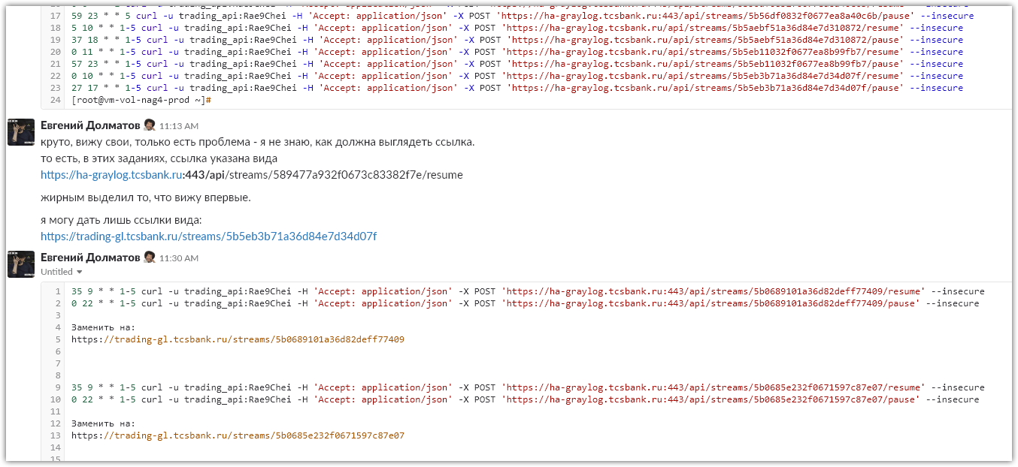

# New Stream ID can be found here. It’s a part of URL to it.
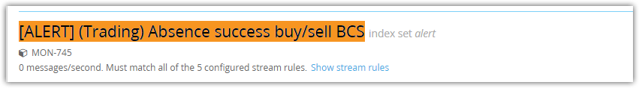
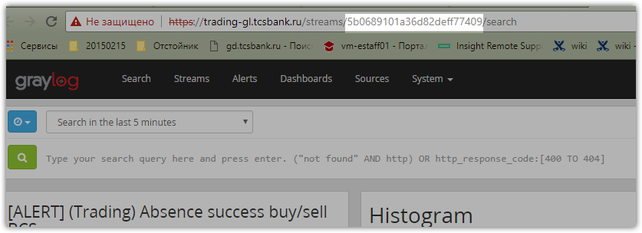

# I tried to test the first line.
[root@vm-vol-nag4-prod ~]# curl -u trading_api:***** -H 'Accept: application/json' -X GET 'https://ha-graylog.tcsbank.ru/api/streams/5b0689101a36d82deff77409/' --insecure --silent | jq '.title,.creator_user_id,.description,.rules[2].value'
"[ALERT] (Trading) Absence success buy/sell BCS"
"o.a.filippova"
"MON-745"
"((ds|m1)-mss-tta-(uat|prod)-api0(1|2).tcsbank.ru)|((m1|ds)-mss-tta-prod-api0(3|4).tcsbank.ru)"
[root@vm-vol-nag4-prod ~]#

# Here I’ve changed server name and Stream ID.
# And have gotten nothign.
[root@vm-vol-nag4-prod ~]# curl -u trading_api:***** -H 'Accept: application/json' -X GET 'https://trading-gl.tcsbank.ru/api/streams/5b0689101a36d82deff77409/' --insecure --silent | jq '.title,.creator_user_id,.description,.rules[2].value'
[root@vm-vol-nag4-prod ~]#

[root@vm-vol-nag4-prod ~]# curl -u trading_api:***** -H 'Accept: application/json' -X GET 'https://trading-gl.tcsbank.ru/api/streams/5b0689101a36d82deff77409/' --insecure | jq '.title,.creator_user_id,.description,.rules[2].value'
% Total % Received % Xferd Average Speed Time Time Time Current
Dload Upload Total Spent Left Speed
0 0 0 0 0 0 0 0 --:--:-- --:--:-- --:--:-- 0
[root@vm-vol-nag4-prod ~]#

#
# That was because appropriate local user “trading_api” was not created on GrayLog server trading-gl.tcsbank.ru.
# Before, I had supposed that password was differ, but the user was absent at all...

# I’ve created the user and assing to it new password.
# After that, recuqest start work properly.
#
[root@vm-vol-nag4-prod ~]# curl -u trading_api:***** -H 'Accept: application/json' -X GET 'https://trading-gl.tcsbank.ru/api/streams/5b0689101a36d82deff77409/' --insecure | jq '.title,.creator_user_id,.description,.rules[2].value'
% Total % Received % Xferd Average Speed Time Time Time Current
Dload Upload Total Spent Left Speed
101 1833 101 1833 0 0 9126 0 --:--:-- --:--:-- --:--:-- 13187
"[ALERT] (Trading) Absence success buy/sell BCS"
"a.leonov"
"MON-745"
"Tinkoff"
[root@vm-vol-nag4-prod ~]#

#
# Some name of Streams were not changed.
#
[root@vm-vol-nag4-prod cron]# curl -u trading_api:***** -H 'Accept: application/json' -X GET 'https://ha-graylog.tcsbank.ru/api/streams/5b0685e232f0671597c87e07/' --insecure --silent | jq '.title,.creator_user_id,.description,.rules[2].value'
"[ALERT] (Trading) Absence success buy/sell Tinkoff"
"o.a.filippova"
"MON-745"
"Tinkoff"
[root@vm-vol-nag4-prod cron]# curl -u trading_api:***** -H 'Accept: application/json' -X GET 'https://trading-gl.tcsbank.ru/api/streams/5b0685e232f0671597c87e07/' --insecure --silent | jq '.title,.creator_user_id,.description,.rules[2].value'
"[ALERT] (Trading) Absence success buy/sell Tinkoff"
"a.leonov"
"MON-745"
"Tinkoff"
[root@vm-vol-nag4-prod cron]#

[root@vm-vol-nag4-prod cron]# crontab -e -u root
crontab: installing new crontab
[root@vm-vol-nag4-prod cron]#

#
# Some of them were been changed.
[root@vm-vol-nag4-prod cron]# curl -u trading_api:***** -H 'Accept: application/json' -X GET 'https://ha-graylog.tcsbank.ru/api/streams/5b5aebf51a36d84e7d310872/' --insecure --silent | jq '.title,.creato
r_user_id,.description,.rules[2].value'
"[ALERT] (Trading) Ошибки «Биржа закрыта» по российским акциям"
"a.leonov"
"SD1569252"
"Price was fetched from middle-office service successfully for ticker"
[root@vm-vol-nag4-prod cron]# curl -u trading_api:***** -H 'Accept: application/json' -X GET 'https://trading-gl.tcsbank.ru/api/streams/5b5aebf51a36d84e7d310872/' --insecure --silent | jq '.title,.creator_user_id,.description,.rules[2].value'
"[ALERT] (Trading) Ошибки «Биржа закрыта» по рублёвым бумагам"
"a.leonov"
"SD1569252"
"(ds|m1-mss-tta-prod-api-01|02|03|04.tcsbank.ru)"
[root@vm-vol-nag4-prod cron]#

#
# After changes.
[root@vm-vol-nag4-prod cron]# crontab -l | grep -e "curl" | sed -e 's/^#//' -e 's/^\(.*\)-u.*\(-H.*\)$/\1-u ***** \2/'
0 11 * * 1-5 curl -u ***** -H 'Accept: application/json' -X POST 'https://ha-graylog.tcsbank.ru:443/api/streams/589477a932f0673c83382f7e/resume' --insecure
0 11 * * 1-5 curl -u ***** -H 'Accept: application/json' -X POST 'https://ha-graylog.tcsbank.ru:443/api/streams/5894883632f0673c83384621/resume' --insecure
0 23 * * 1-5 curl -u ***** -H 'Accept: application/json' -X POST 'https://ha-graylog.tcsbank.ru:443/api/streams/589477a932f0673c83382f7e/pause' --insecure
0 23 * * 1-5 curl -u ***** -H 'Accept: application/json' -X POST 'https://ha-graylog.tcsbank.ru:443/api/streams/5894883632f0673c83384621/pause' --insecure
5 10 * * 1-5 curl -u ***** -H 'Accept: application/json' -X POST 'https://ha-graylog.tcsbank.ru:443/api/streams/5aaf6d5632f067154eebc6c2/resume' --insecure
59 23 * * 1-5 curl -u ***** -H 'Accept: application/json' -X POST 'https://ha-graylog.tcsbank.ru:443/api/streams/5aaf6d5632f067154eebc6c2/pause' --insecure
35 9 * * 1-5 curl -u ***** -H 'Accept: application/json' -X POST 'https://trading-gl.tcsbank.ru/api/streams/5b0689101a36d82deff77409/resume' --insecure
0 22 * * 1-5 curl -u ***** -H 'Accept: application/json' -X POST 'https://trading-gl.tcsbank.ru/api/streams/5b0689101a36d82deff77409/pause' --insecure
35 9 * * 1-5 curl -u ***** -H 'Accept: application/json' -X POST 'https://trading-gl.tcsbank.ru/api/streams/5b0685e232f0671597c87e07/resume' --insecure
0 22 * * 1-5 curl -u ***** -H 'Accept: application/json' -X POST 'https://trading-gl.tcsbank.ru/api/streams/5b0685e232f0671597c87e07/pause' --insecure
00 10 * * 1-5 curl -u ***** -H 'Accept: application/json' -X POST 'https://ha-graylog.tcsbank.ru:443/api/streams/5b55c75132f0677ea8a2d9fa/resume' --insecure
59 23 * * 1-5 curl -u ***** -H 'Accept: application/json' -X POST 'https://ha-graylog.tcsbank.ru:443/api/streams/5b55c75132f0677ea8a2d9fa/pause' --insecure
0 0 * * 1-5 curl -u ***** -H 'Accept: application/json' -X POST 'https://ha-graylog.tcsbank.ru:443/api/streams/5b56d7db1a36d84e7dd89ee5/resume' --insecure
0 10 * * 1-5 curl -u ***** -H 'Accept: application/json' -X POST 'https://ha-graylog.tcsbank.ru:443/api/streams/5b56d7db1a36d84e7dd89ee5/pause' --insecure
0 0 * * 1 curl -u ***** -H 'Accept: application/json' -X POST 'https://ha-graylog.tcsbank.ru:443/api/streams/5b56df0832f0677ea8a40c6b/resume' --insecure
59 23 * * 5 curl -u ***** -H 'Accept: application/json' -X POST 'https://ha-graylog.tcsbank.ru:443/api/streams/5b56df0832f0677ea8a40c6b/pause' --insecure
5 10 * * 1-5 curl -u ***** -H 'Accept: application/json' -X POST 'https://trading-gl.tcsbank.ru/api/streams/5b5aebf51a36d84e7d310872/resume' --insecure
37 18 * * 1-5 curl -u ***** -H 'Accept: application/json' -X POST 'https://trading-gl.tcsbank.ru/api/streams/5b5aebf51a36d84e7d310872/pause' --insecure
0 11 * * 1-5 curl -u ***** -H 'Accept: application/json' -X POST 'https://trading-gl.tcsbank.ru/api/streams/5b5eb11032f0677ea8b99fb7/resume' --insecure
57 23 * * 1-5 curl -u ***** -H 'Accept: application/json' -X POST 'https://trading-gl.tcsbank.ru/api/streams/5b5eb11032f0677ea8b99fb7/pause' --insecure
0 10 * * 1-5 curl -u ***** -H 'Accept: application/json' -X POST 'https://trading-gl.tcsbank.ru/api/streams/5b5eb3b71a36d84e7d34d07f/resume' --insecure
27 17 * * 1-5 curl -u ***** -H 'Accept: application/json' -X POST 'https://trading-gl.tcsbank.ru/api/streams/5b5eb3b71a36d84e7d34d07f/pause' --insecure
[root@vm-vol-nag4-prod cron]#

